
Business Question and Visualization Report

Date | 1 November 2026
Team ID
Project Name | Electric Vehicle Market Performance & insights
Maximum Marks | 5 Marks

Visualization development involves converting raw EV market data into graphical representations for better understanding, analysis, and decision-making. This project uses Snowflake and Tableau to analyze over 200,000 electric vehicle records and identify sales trends, manufacturer performance, regional distribution, pricing, and driving range.

Business Questions and Visualisation

The process involves defining specific business questions to guide the creation of meaningful visualizations in Tableau. These questions help identify important EV market trends, compare manufacturers, analyze vehicle categories, and generate useful business insights.

Sample Business Questions

- Which manufacturers have the highest annual EV sales?

- Visualization: Horizontal Bar Chart comparing manufacturer-wise sales.

- How are EV categories distributed across different market regions?

- Visualization: Heatmap showing category-wise regional performance.

- How do different manufacturers perform across EV categories?

- Visualization: Stacked Bar Chart showing manufacturer-wise category sales.

- What are the yearly trends in EV sales?

- Visualization: Line Chart showing annual sales trends.

- Which EV categories have the highest average prices?

- Visualization: Bar Chart comparing average prices by category.

- What is the relationship between EV prices and driving range?

- Visualization: Scatter Plot comparing vehicle prices and driving range.

- Which EV categories contribute the most to total market sales?

- Visualization: Treemap showing category-wise sales contribution.

- How does EV market performance vary across different regions?

- Visualization: Regional Heatmap comparing EV market performance.
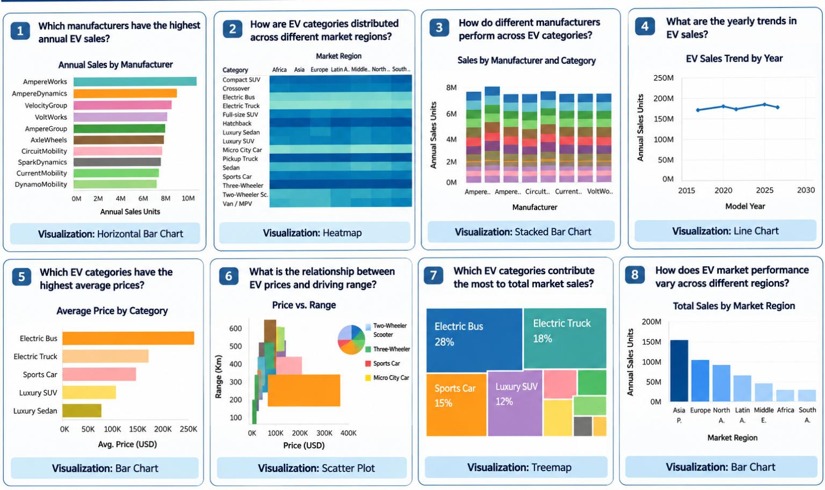

Note: Minimum 8 business questions and their corresponding visualizations are included as required.

